**Penugasan**

* + 1. Buatlah kode program untuk menghitung dan mencetak keliling dan luas persegi, persegi panjang, trapezium

Screenshot Kode Program

|  |
| --- |
|  |

Screenshot Hasil

|  |
| --- |
|  |

* + 1. Buatlah kode program untuk menghitung dan mencetak volume tabung dan balok

Screenshot Kode Program

|  |
| --- |
|  |

Screenshot Hasil

|  |
| --- |
|  |

* + 1. Buatlah kode program untuk menghitung dan mencetak nilai ganjil dan genap

Screenshot Kode Program

|  |
| --- |
|  |

Screenshot Hasil

|  |
| --- |
|  |

* + 1. Buatlah kode program seperti pada gambar di bawah ini!

Screenshot Kode Program

|  |
| --- |
|  |

Screenshot Hasil

|  |
| --- |
|  |

* + 1. Buatlah kode program seperti pada gambar di bawah ini!

Screenshot Kode Program

|  |
| --- |
|  |

Screenshot Hasil

|  |
| --- |
|  |

* + 1. Buatlah kode program berdasarkan flowchart di bawah ini!

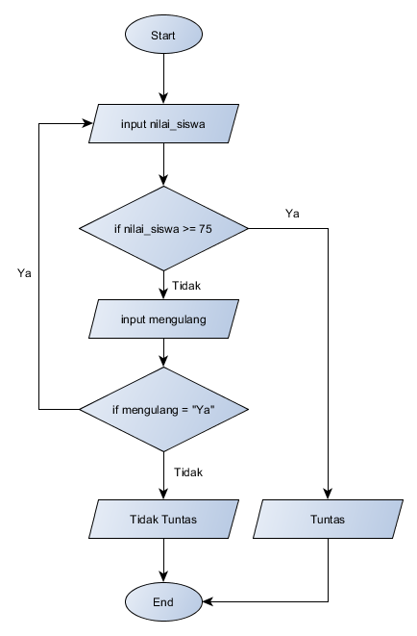

Screenshot Kode Program

|  |
| --- |
|  |

Screenshot Hasil

|  |
| --- |
|  |

* + 1. Buatlah kode program berdasarkan flowchart di bawah ini!

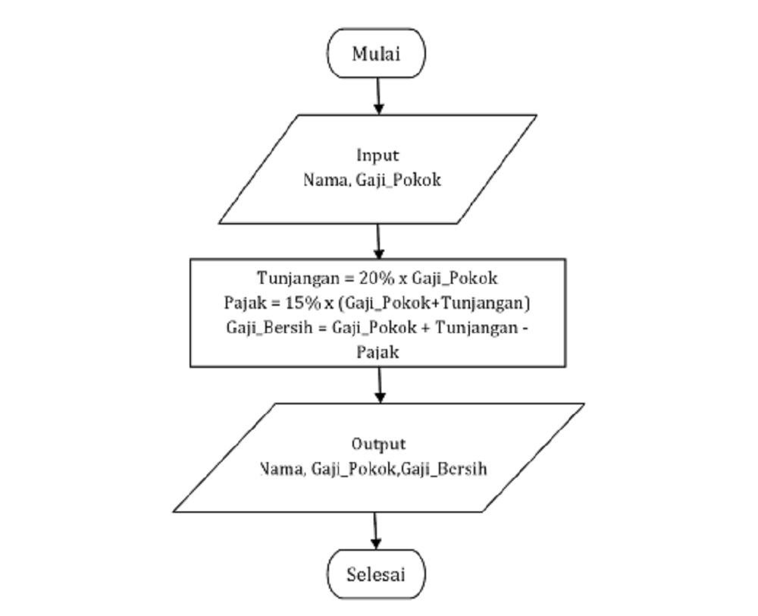

Screenshot Kode Program

|  |
| --- |
|  |

Screenshot Hasil

|  |
| --- |
|  |

* + 1. Buatlah kode program berdasarkan flowchart di bawah ini!

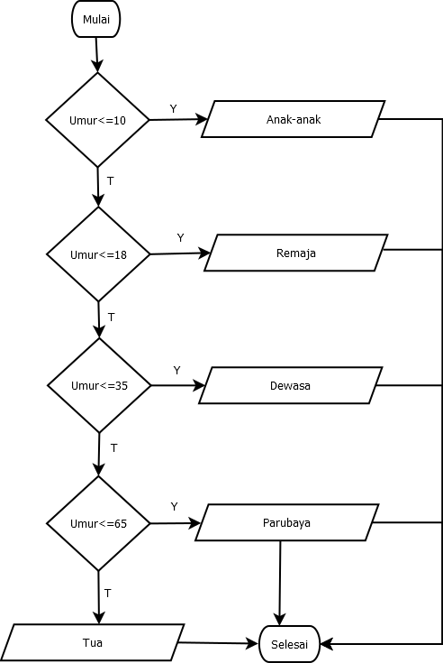

Screenshot Kode Program

|  |
| --- |
|  |

Screenshot Hasil

|  |
| --- |
|  |

* + 1. Buatlah kode program berdasarkan flowchart di bawah ini!

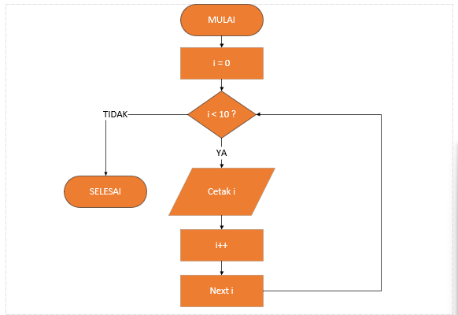

Screenshot Kode Program

|  |
| --- |
|  |

Screenshot Hasil

|  |
| --- |
|  |

* + 1. Buatlah kode program berdasarkan flowchart di bawah ini!

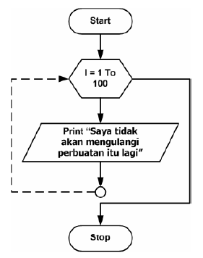

Screenshot Kode Program

|  |
| --- |
|  |

Screenshot Hasil

|  |
| --- |
|  |